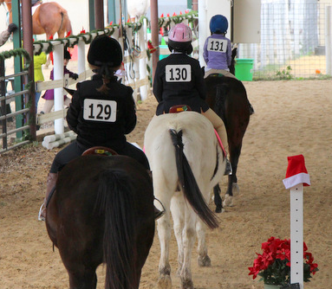
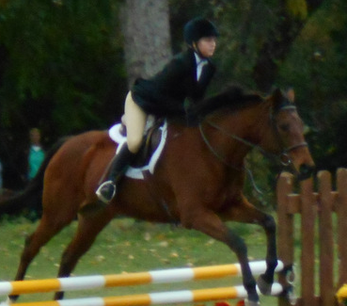

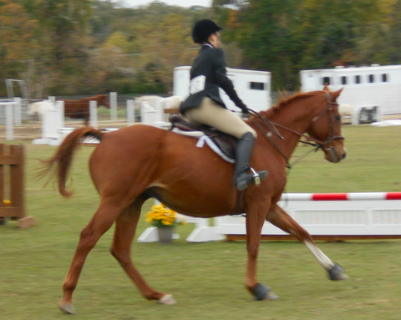
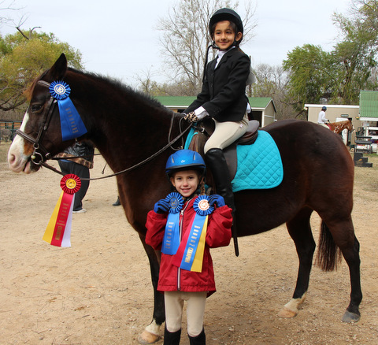
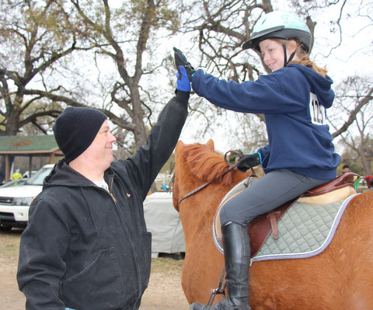
9:00 AM, DECEMBER 2nd, 2017
JUDGE: JESSICA LINDER

TRINITY RIVER FARM PRESENTS:

3rd ANNUAL SCHOOLING SHOW
Information

Fees
Early entry fees for equitation divisions are $15 per class, if received by 5 pm Sunday, November 28th. After that time, all email or day of entries are $20 per class. Hunter Derby entries are $20 per class in advanced, $25 per class after Wednesday. Please register as early as possible to allow us the proper time to prepare for you and create a great show experience! All riders will be charged a one time $20 registration/awards fee.
Schooling
Grounds will open at 7:15am to outside riders. Schooling will be from 7:45 to 8:45am in the jump field. After that time schooling will be permitted in the covered arena or XC field. There will be a schooling break before Xs and poles classes.
Attire
Half chaps and paddock boots are acceptable and coats are optional. If not wearing a coat, a neat collared shirt and plain colored breeches are suggested. Dress warm as it will likely be cold! Riders must wear protective helmets at all times while mounted!
Cross Entries
Cross entries are encouraged, however riders are not allowed to cross-enter into divisions with more than a 6” height difference. Riders should not school fences more than 6” higher than the divisions they are entered in. There are no restrictions on cross-entries for horses.
Coggins
Texas state law requires proof of a negative Coggins report within one year of the show date. This must be shown at check in, no exceptions!
Miscellaneous
Dogs are not allowed. Refreshments and horse treats will be available throughout the day for purchase.
Children must be supervised by an adult at all times.
Management reserves the right to change, combine, or eliminate classes in the event of insufficient entries.
Trailer parking is available. Please see map for instructions on where to park.
Entries
Please email entries to trinityriverfarmtx@sbcglobal.net. Include name of rider, horse, class numbers, barn, trainer name and phone number.
Contact Information
For more information, please email us at trinityriverfarmtx@sbcglobal.net or call
817-683-5610.
WARNING
Under Texas law (Chapter 87, Civil Practice and Remedies Code), a livestock show sponsor is not liable for an injury to or the death of a participant in a livestock show resulting from the inherent risks of livestock show activities. All participants must sign a liability release form.
Class List

DIVISION I: BEGINNER EQUITATION
Walk Trot Over Poles
1. Warm-up Class - Equitation over Poles (Does not count towards division champ; optional)
2. Equitation over Poles (tracking left)
3. Equitation over Poles (tracking right)
4. Equitation on the Flat

DIVISION II: LIMIT RIDER EQUITATION
Walk-Trot Over Cross Rails 18"
5. Warm-up Class- Equitation over Crossrails (Does not count towards division champ; optional)
6. Equitation over Cross Rails (tracking left)
7. Equitation over Cross Rails (tracking right)
8. Equitation on the Flat

DIVISION III: LIMIT RIDER EQUITATION
Walk Trot Canter Over Cross Rails 18"
9. Warm-up - Equitation over Crossrails (Does not count towards division champ; optional)
10. Equitation over Cross Rails (tracking left)
11. Equitation over Cross Rails (tracking right)
12. Equitation on the Flat

DIVISION IV: 18" Equitation
13. Warm-up Class – Equitation over fences (Does not count towards division champ; optional)
- Equitation on the Flat
- Equitation over Fences
- Medal class (will include work off)

DIVISION V: 2'0" Equitation
17. Warm-up Class – Equitation over Fences (Does not count towards division champ; optional)
18. Equitation on the Flat
19. Equitation over Fences
20. Medal class (will include work off)

DIVISION VII: 2'3" Equitation
21. Warm-up Class - Equitation over Fences (Does not count towards division champ; optional)
22. Equitation on the Flat
23. Equitation over Fences
24. Medal class (will include work off)

DIVISION VIII: 2'6" Equitation
25. Warm-up Class – Equitation over Fences (Does not count towards division champ; optional)
26. Equitation on the Flat
27. Equitation over Fences
28. Medal class (will include work off)

DIVISION IX: 2'9" Equitation
29. Warm-up Class – Equitation over Fences (Does not count towards division champ; optional)
30. Equitation on the Flat
31. Equitation over Fences
32. Medal class (will include work off)

DIVISION X: Hunter Derby (Fences at 2’6-2’9)
29. Warm-up Class – Hunter over Fences (Does not count towards division champ; optional)
30. Hunter over Fences
31. Handy Hunter over Fences

DIVISION XI: Leadline
Open to young riders 6 and under; lead by parent/sibling.
32. Leadline Class

TRINITY RIVER FARM
3rd ANNUAL HORSE SHOW - DECEMBER 2ND, 2017
Entry Form
Note: Lead Line Riders must complete an entry form.

Entry Forms are due Sunday November 26th, 2017 if you are using a
TRINITY RIVER FARM school horse, or Wednesday, November 29th if you are bringing your own horse. School horses are available on a first come, first serve basis.
Show Classes/$15 each  Hunter Derby Classes/$20 each | _____ classes @ $15 = _______  _____ classes @ $20 = _______
Office Fee | $20.00
Payment Method (circle): Cash Check  Date: _____/______/______ | Total Amount Due: $_______________

Rider Info:
Rider Name: _______________________________________________ Age: ________

Class Numbers: _________________________________________________________________________

Parent Info:
Parent’s Name & Phone Number: _____________________________________________

Volunteering for: __ Ring Steward __ Tack-up Helper __ Jump Crew
__ Announcer __ Concessions __ Judges Assistant ___ Parking Assistance

Trainer/Horse Info (Outside Stables Only):

Trainer Name: Horse Name:
Stable Name:

**Please speak with your instructor about which classes you should enter**
**Please make every effort to volunteer in some capacity. This keeps show fees down and helps things move more smoothly day of**

Office Phone: 817-683-5610
Email: trinityriverfarmtx@sbcglobal.net
TRINITY RIVER FARM & EQUESTRIAN CENTER
LIABILITY RELEASE II

RIDER NAME: AGE (IF UNDER 21)

This release of liability is made and entred into on this the day of , 20 , by
and between Julie Amendola hereinafter designated Manager and , hereinafter designated rider; and if rider is a minor, Rider’s Parents or legal guardian. In return for the use today and all days in the future of the property, facilities and service of the manager, the rider or legal guardians, his heirs, assigns and legal representatives, hereby expressly agree to the following:

I AGREE THAT: Should emergency medical treatment be required, that Trinity River Farm and its representatives are authorized to seek medical care in my behalf, or my child (if rider is a minor) and I and/or my own health insurance company shall pay for all such incurred expenses.

Parent or Rider Must Initial Below for Each Paragraph:

_____ 1.The rider is responsible for full and complete insurance coverage on his horse, his personal property and himself.
_____ 2. The rider understands that there are RISKS IN AND ROUND ALL EQUINE ACTIVITIES, and that an equine activity sponsor, professional, manager or instructor is not liable for any injury to, or death of, a rider and/or a participant in an equine activity resulting from the inherent risk of equine activities.
_____ 3. The rider agrees any and all risk involved in or arising from riders use of or presence upon manager/instructor property and facilities including but not limited to: the risk of death, bodily injury, property damage, falls, kicks, bites, collision of vehicles, horses or other stationary objects, fire, acts of God, and the unavailability of medical emergency attention.
_____ 4. The rider and/or parents or guardians agree to hold harmless the manager/instructor and all successors, assigns, subsidiaries, franchises, affiliates, officers, directors, employees and agents and not liable and release them from all liability whatsoever and agree NOT TO SUE them on account of or in connection with any claim of injury damage, cost or expenses arising out of rider’s use of the property or facilities, including without limitations to those based on death, bodily injury, property damage, including consequential damages, except if the damages are caused by willful and direct gross negligence on the part of the manager/instructor.
_____ 5. The rider agrees to defend manager/instructor against, and hold harmless from any and all claims due to damages, judgments, or any other costs, including but not limited to attorney’s fees, which result from the rider’s use of the manager/instructor’s property or facility.
_____ 6. Riders agrees to follow safety rules and regulations and is required to wear PROTECTIVE HEADGEAR and smooth soled boots at all times when mounted.
_____ 7. This contract is not-assignable and non-transferable and is made in and entered into the State of Texas, and shall be enforced and interpreted under the laws of the State of Texas. Should any clause be in conflict with the State Laws, then that clause is null and void.
THIS CONTACT , WHEN SIGNED, IS BINDING ON BOTH PARTIES SUBJECT TO THE TERMS LISTED ABOVE.
**WARNING** UNDER TEXAS LAW (CHAPTER 87, CIVIL PRACTICE AND REMIDES CODE), AN EQUINE PROFESSIONAL IS NOT LIABLE FOR AN INJURY TO OR THE DEATH OF A PARTICIPANT IN EQUINE ACTIVITIES RESULTING FROM THE INHERENT RISK OF EQUINE ACTIVITIES.

SIGNATURE OF RIDER (ADULT) PRINTED NAME OF RIDER DATE

SIGNATURE OF PARENT (MOTHER) for PRINTED NAME OF RIDER DATE

SIGNATURE OF PARENT (FATHER) for PRINTED NAME OF RIDER DATE

SIGNATURE OF LEGAL GUARDIAN for PRINTED NAME OF RIDER DATE

Trail
Pond
Pasture

DO NOT ENTER
Restrooms
Main Barn

Trailer Parking
Goat Barn

DO NOT ENTER
Covered Arena
(Warm up + Poles and Xs)

Concessions/Check in
Wash Rack

Warm Up Area 1
Warm Up Area 2
XC area

DO NOT JUMP XC JUMPS
Jump Field
(18”-2’9 classes)
Pasture

DO NOT ENTER

